**HackSpace**

**Line following robot initial build spec**

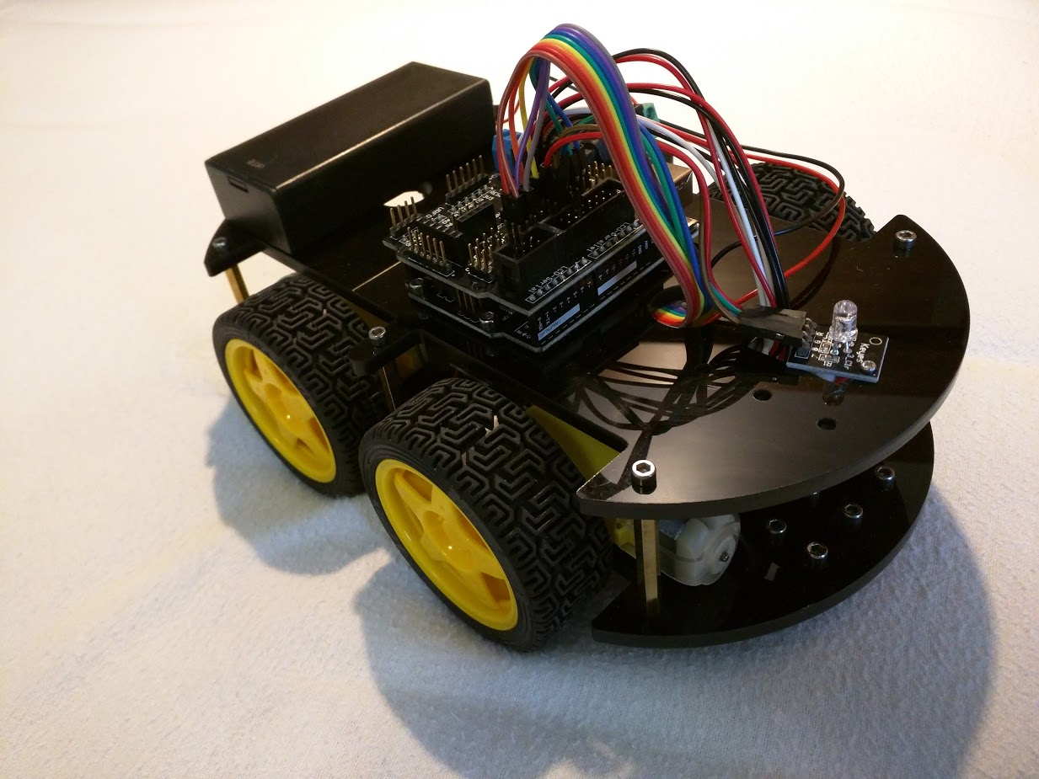

1. Motor alignment

As shown in the diagram, the two front motors (at the bottom right of the picture) should have their red (+ve) cables uppermost, and the two rear facing motors (upper left of the picture) should have their black (-ve) cables uppermost.

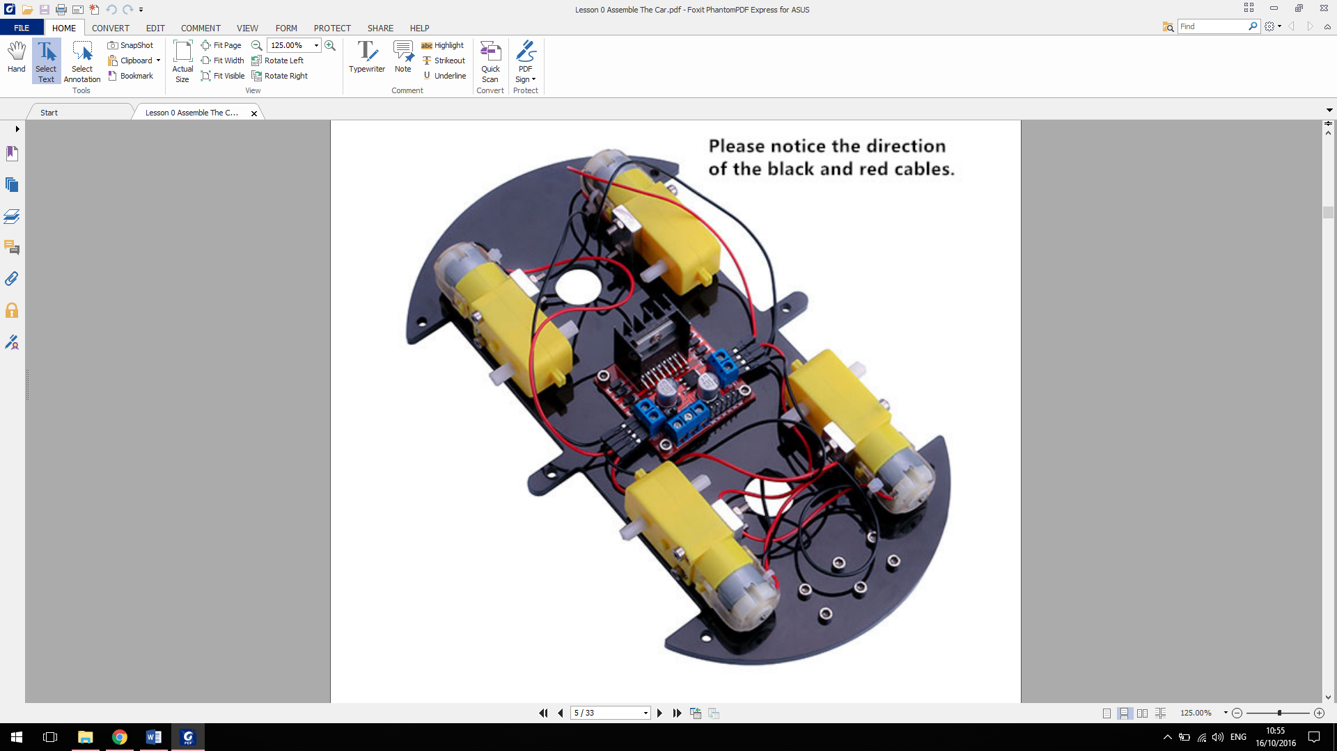

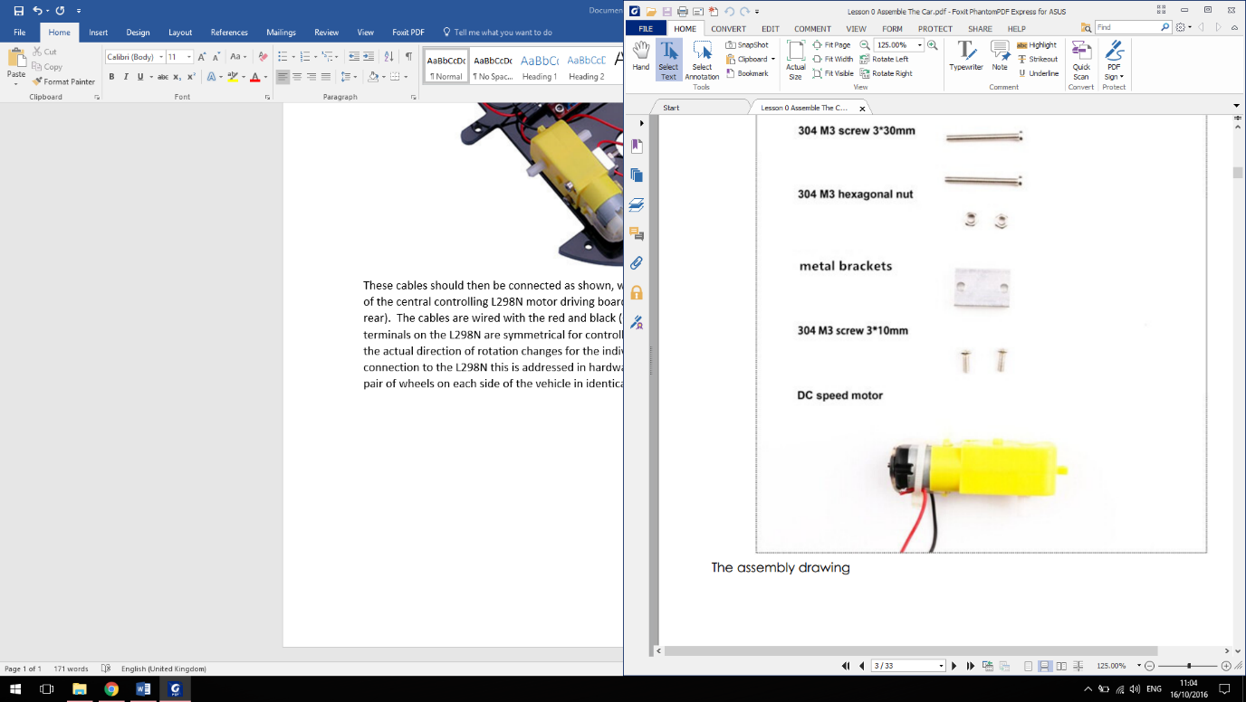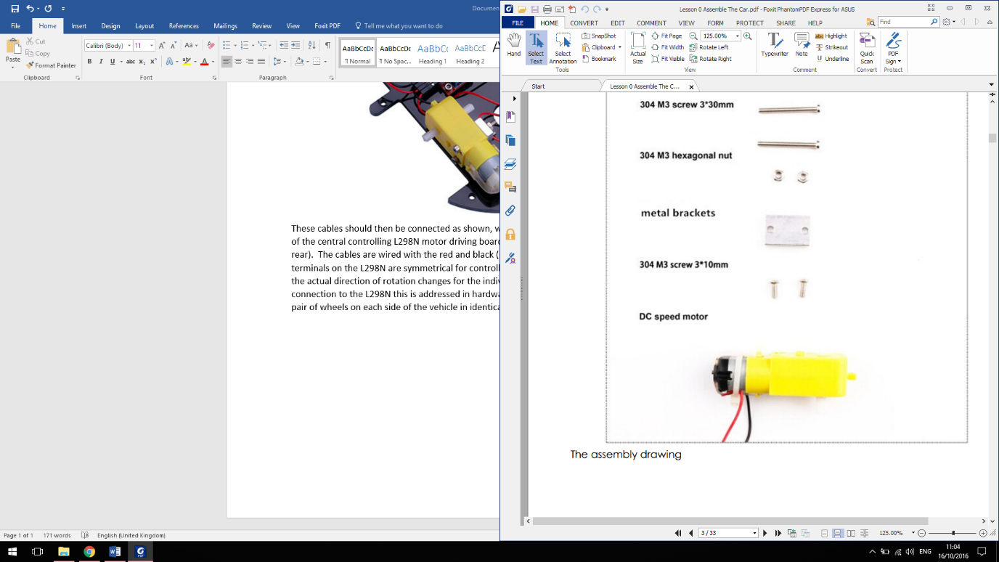These cables are connected as shown, with each side of the vehicle connected to a side of the central controlling L298N motor driving board (installed with the heat sink to the rear). The cables are wired with the red and black (+ve and -ve) into opposite power terminals on each side so that the terminals on the L298N are symmetrical for controlling forwards and backwards motion in code. The actual direction of rotation changes for individual motors, but by switching the red and black connection to the L298N for each side of the vehicle this is addressed in hardware and enables the programming to control the pair of wheels on each side of the vehicle in identical terms for forward and backward motion.

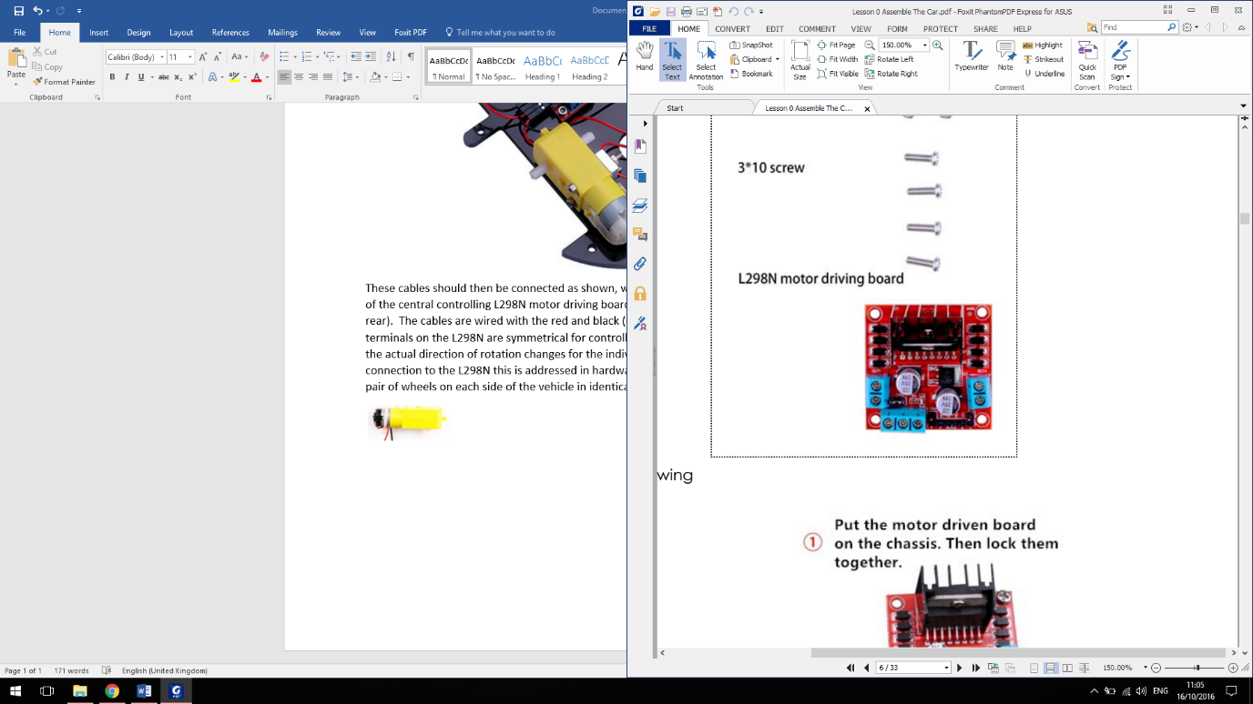Black wire uppermost on motors

Red wire uppermost on motors

Power from battery pack

1. Arduino Sensor Shield connections

The robot is controlled by an Arduino controller, which has a further sensor shield installed on top of it to provide additional input/output points. In the initial build of the line following robot the setup is:

|  |  |  |  |
| --- | --- | --- | --- |
| **Shield ID** | **Pin # (in code)** | **Connected to** | **Wire(s) colour** |
| 0 | 0 | - |  |
| 1 | 1 | - |  |
| 2 | 2 | - |  |
| 3 (PWM) | 3 | - |  |
| 4 | 4 | - |  |
| 5 (PWM) | 5 | ENA on motor board (power to left) | Red (Brown to V) |
| 6 (PWM) | 6 | ENB on motor board (power to right) | Purple (Grey to V) |
| 7 | 7 | N1 on motor board | Orange |
| 8 | 8 | N2 on motor board | Yellow |
| 9 (PWM) | 9 | Red input to LED | Red |
| 10 (PWM) | 10 | Green input to LED | Green |
| 11 (PWM) | 11 | Blue input to LED | Blue |
| 12 | 12 | N3 on motor board | Green |
| 13 | 13 | N4 on motor board | Blue |
| A0 | 14 | Left optical sensor input | White, Red, Black |
| A1 | 15 | Middle optical sensor input | White, Red, Black |
| A2 | 16 | Right optical sensor input | White, Red, Black |
| A3 | 17 | - |  |
| A4 | 18 | - |  |
| A5 | 19 | - |  |

For each numbered point on the shield there are 3 connections (labelled S, V and G) these are; Signal, Volts (5V) and Ground). The input/output pin is the bottom S pin, and the additional power pins are only needed where additional power is required (the ENA/ENB connections to the motors and for the optical sensors).

Pins 0-13 are digital Input-Output and A0-A5 are analogue (thus the ‘A’ prefix). Of the digital pins numbers; 3,5,6,9,10,11 are Pulse Width Modulated (PWM). This means that their input/output is not just a binary ON or OFF but can be set to a specific value from 0-255. These pins have therefore been selected to enable the speed of the motors to be controlled (pins 5 and 6) and to enable more precise control of the colour of the LED (pins 9, 10 and 11).

Note that although the Analogue pins (A0, A1 and A2) are used for the optical sensors the sensors themselves only provide a binary output (line is sensed or not), therefore these pins are being used as if they were digital for this line following robot, and in code they are read with a digitalRead command returning either “HIGH” or “LOW”.

1. Connection diagram

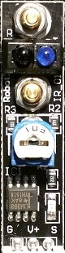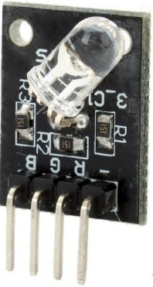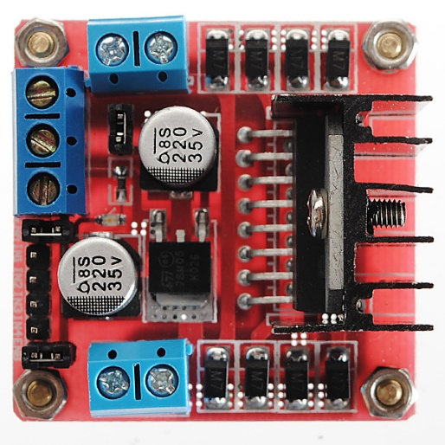(Note; light green used for white wires )

Right Sensor

Centre Sensor

Left Sensor

Vehicle Motor

Vehicle Motor

Vehicle Motor

Battery Pack

(Also connected to Arduino beneath shield)

Vehicle Motor

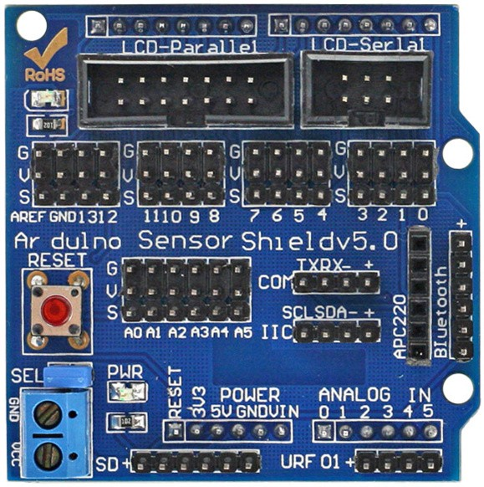

1. 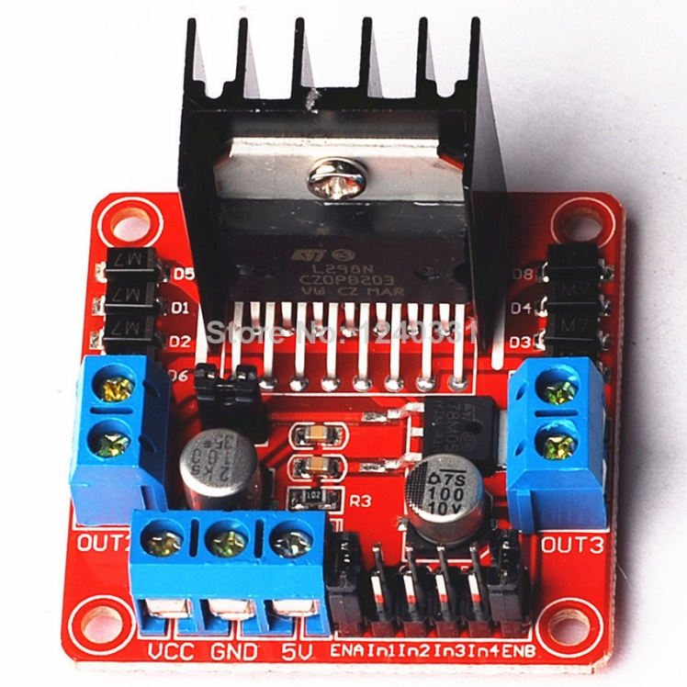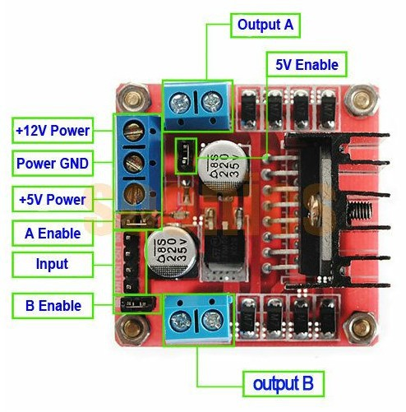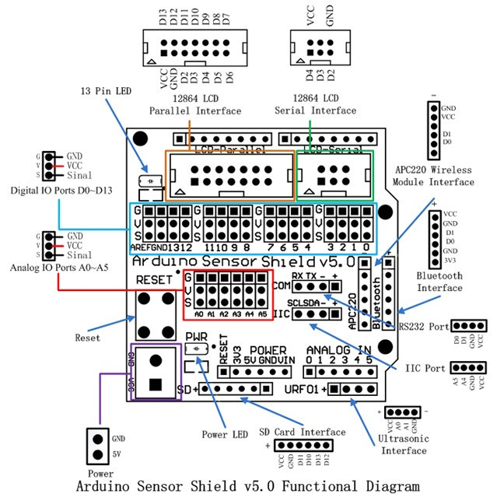Additional information on Arduino Sensor Shield v5.0 and L298N motor control board